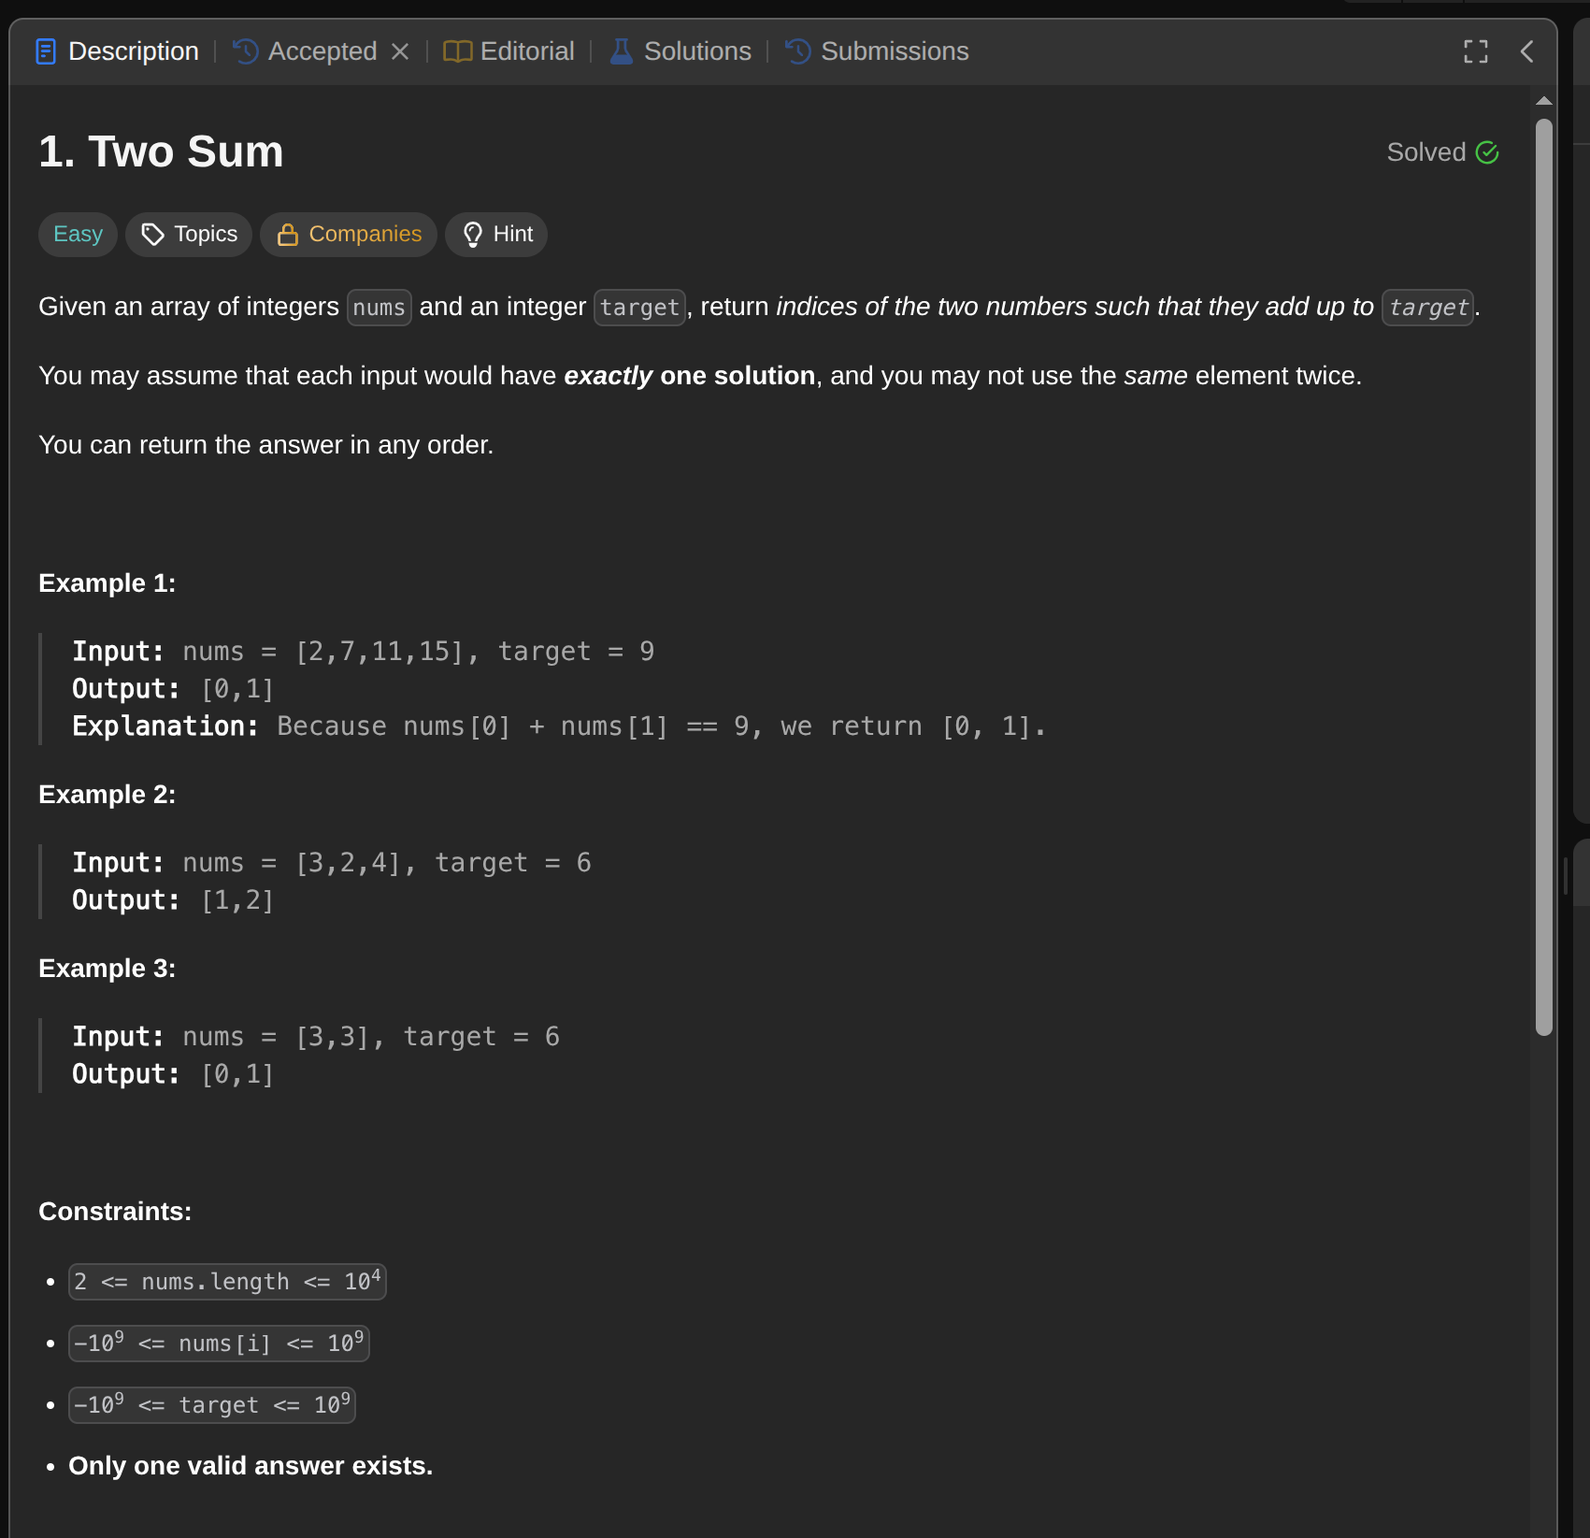

Ground Work:
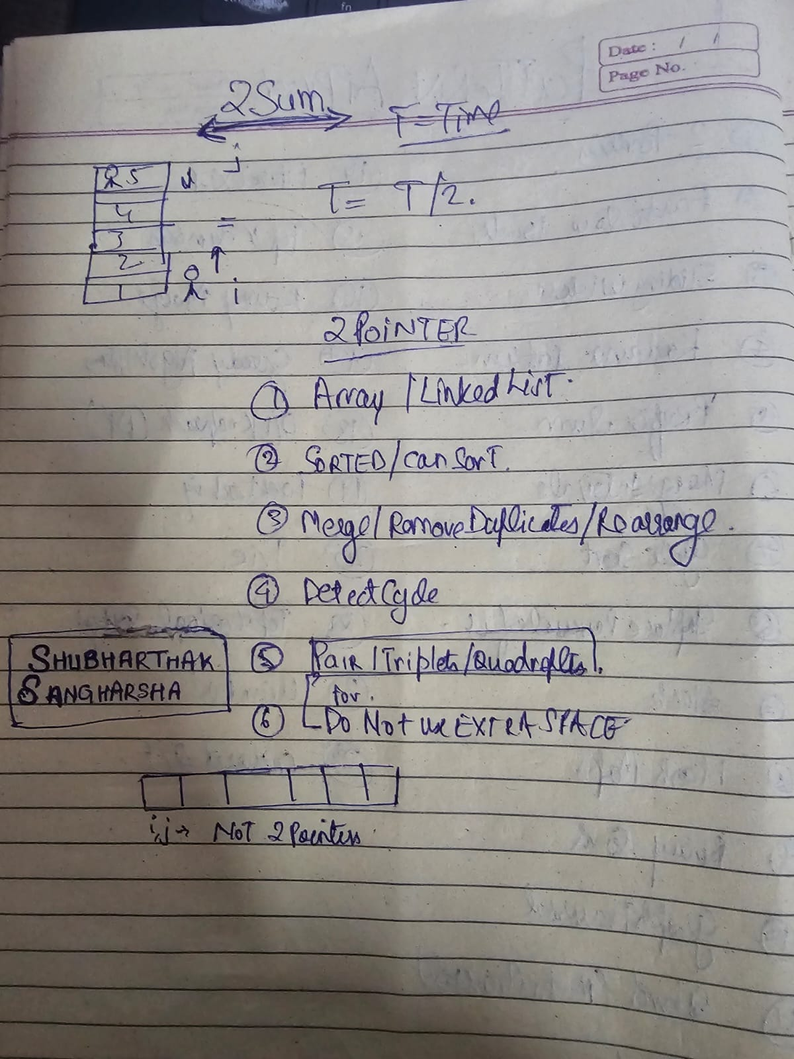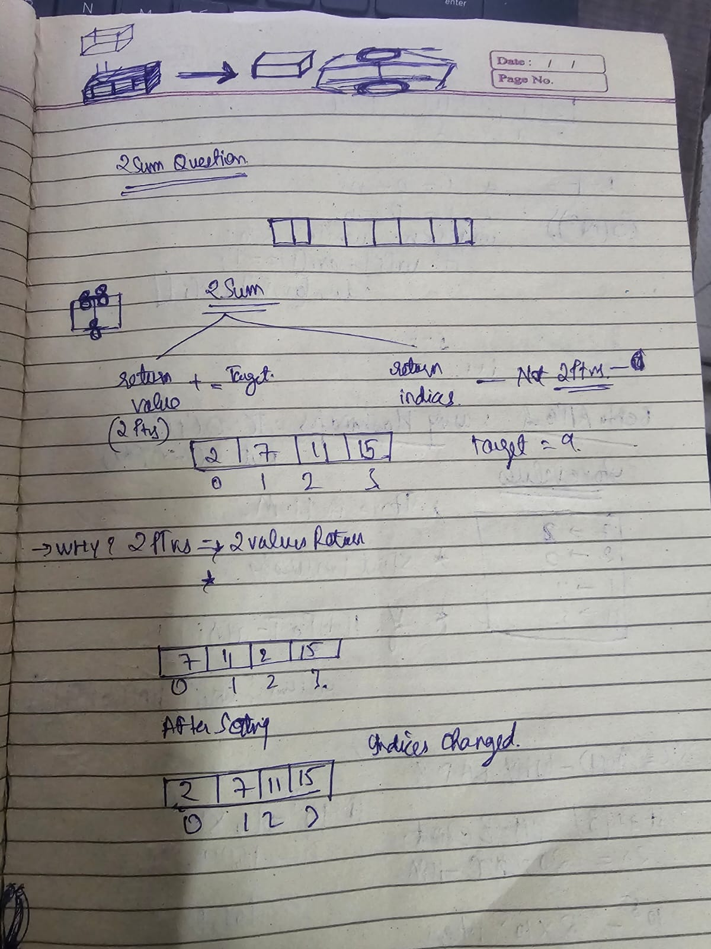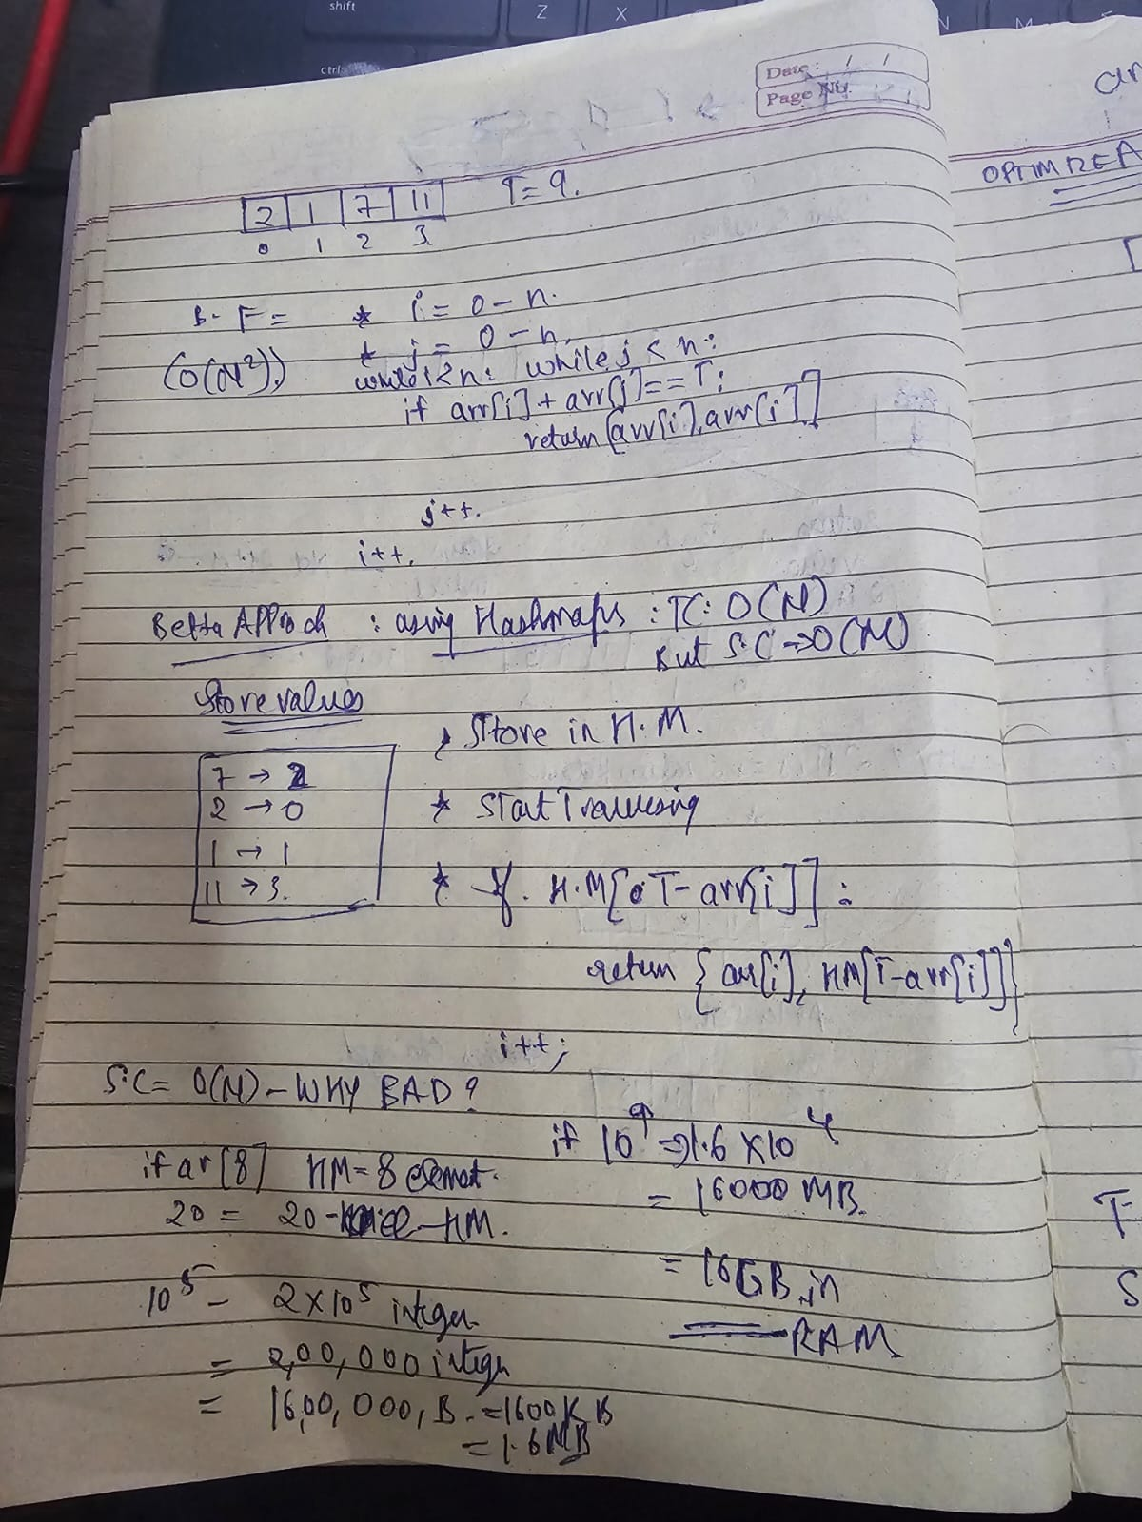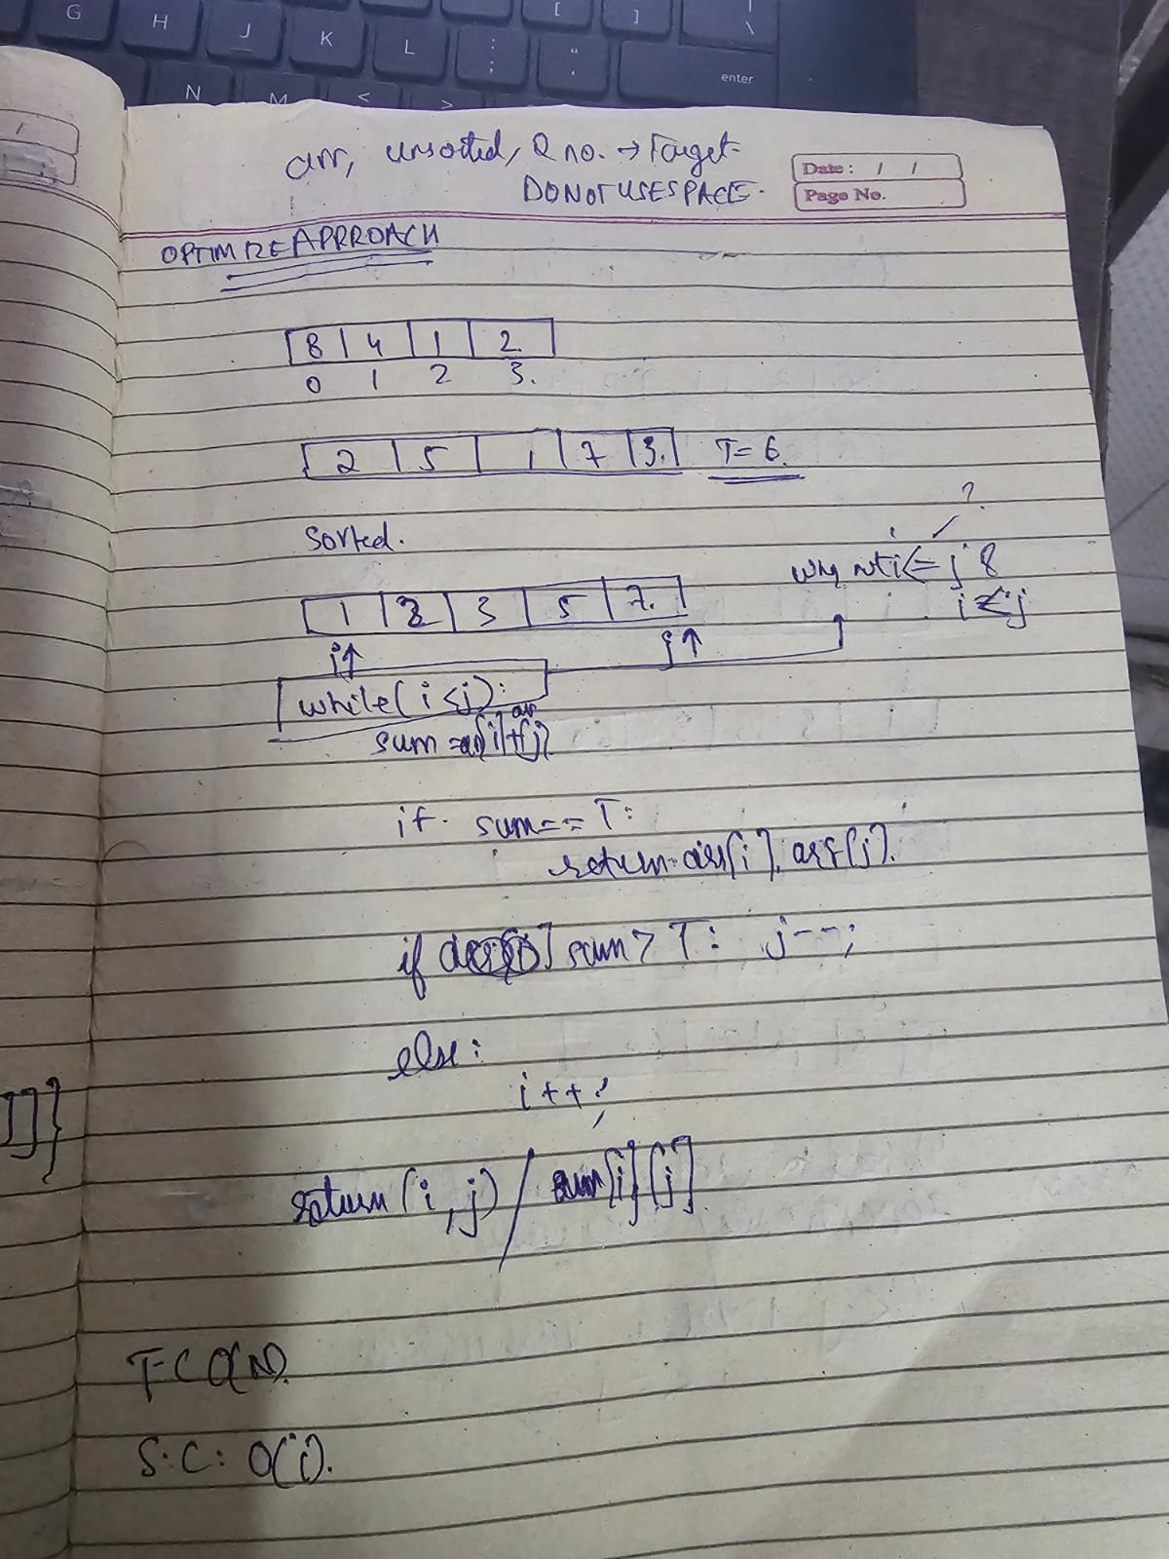

Code:

from typing import List

def twoSum(nums: List[int], target: int) -> List[int]:
# Brute Force tc: O(n^2), SC: O(1)
for i in range(len(nums)):
for j in range(i+1, len(nums)):
if nums[i] + nums[j] == target:
return i, j

# normal 2 pointers approach can't fit here because we need to return the indicies and if we sort them the indicies are loosed
# nums = sorted(nums)
# i, j = 0, len(nums) - 1
# while i < j:
# res = nums[i] + nums[j]
# if res == target:
# return [i, j] # for indices
# # return [nums[i], nums[j]] # for values
# if res > target:
# j -= 1
# else:
# i += 1
# return [-1, -1]

# lets use hash map tc: o(N) and SC: o(N)
hm = {}
for i in range(len(nums)):
find_val = target - nums[i]
if find_val in hm:
return [i, hm[find_val]]
hm[nums[i]] = i

if __name__ == "__main__":
print(twoSum([3, 2, 4], 6))
# print(twoSum([2, 7, 11, 15], 9))

